David Scott 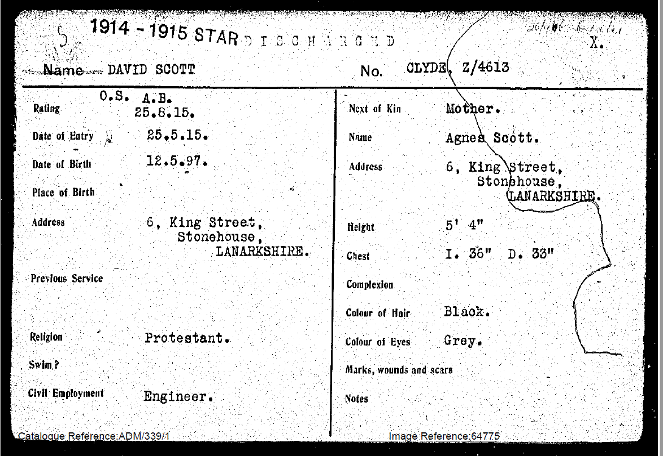
25. 5.15.C.P.Depot (2/I/38)
25. 5.15.Crystal Palace R.N.D. Depot (2/I/38
Res.
13.7.15 . From Depot to Third/Battalion, Blandford.
14. 7.15 . 3rd.Reserve Battalion, Blandford.
23.8.15. Recd. Blandford D.O.28- 21.8.15 . Leave from Noon 21.8.15. till
Midnight 27.8.15.
25.8.15. Rated A.B.
31.8.15. Recd 3rd Res. Bfd .D.O.40, 28.8.15 Ret. Fr. leave 27.8.15.

Oct.1915. Drafted from 3rd Res. Battn Blandford to Drake Battalion M.E.F. (1st Class Machine Gunner)
5.10.15 .Drake Battalion
14.10.15 Recd.B’ford D.O. 71. 4/10/15 (3rd Res) To Drake Battn.a.m 4/10/15
19.10.15 Recd. D.O. 104 6.11.15 Joined Drake Batt. For Duty, 21.10.15

21.7.16 BEF.D.O.54 Emb. HMT.Minneswaska, Murdros, 15.5.16. Disemb. Marseilles,- 20.5.16
24.II.16. HA/4310.Adm.I6. GH.Le.Treport 15.11.16. GSW R.Arm.
24.II.16. NOK informed RND List No. 777
25.11.16 BEF.D.O.86 Invalided to England per H.S. Carisbrooke Castle, from16th Genl.Hosp 19.11.16
27.11.16. H.A.4410. To. Eng. Ex Gen.H. 18.11.16. GSW R.Arm
27.11.16. Rep.recd from Base Record Office “Wounded” 13.11.16. (also BEF.D.O.85)
30.11.16. HB/3202.Adm 3 Scottish GH Stobhill, Glasgow ex Eastleigh, 24.11. SMO informed,
2.12.16. From AFB.103. (Embarked on Minnewaska at Mudros 15.5.16. Disembarked Marseilles 20.5.16.
19.11.16. Invalided to England from Le Treport per H.S Carisbrooke Castle from 16th Genrl Hosp
5.12.16. DO.325. (A.Res) Transfer ex Drake Bn & admitted 3rd Scot.Gen.Hos Glasgow. (24.11.16)
15.12.16. AFW 3119. Transferred from Glasgow Hos. To Lancashire Mil: Conv.Hos. Blackpool, 11.12.16.
22.3.17. D.O./80, (“A” Res. Battn) To Woolwich for Trade Test, 22.3.17
24.3.17 D.O./82 (“A” Res.) From command at Woolwich 24.3.17. A/1706
2.4.17 Submission to N. Branch for discharge to A.O.C.
5.4.17. Discharge approved.
11.4.17. D.O.100. “A” Res. Battn. Discharged for re-enlistment in A.O.C. commencing 11.4.17
18.4.17. Discharged list No 264.
3.5.17. S/C. ,MHS.,AGB/103. Recd. From S.C.O. Blandford
7.5.17. S/C. , forwarded to O/C,Records, A.O.C. Woolwich Dockyard.
25.5.15. Crystal Palace R.N.D. Depot. 2/1/138.
14.7.15. 3rd Res. Battn. A/38.
25.8.15. Rated A.B.
4.10.15. Drake Battn. R2/1886. Character V.G. Ability Sat.
6.2.17. “A” Res. Battn A/1706. Character V.G. Ability Sat.
10.4.17. Discharged for re-enlistment in the Army Ordnance Corps.
Pte. No. 029588, Discharged 28.6.1919
31.12.20 Pro-forma called for from R.O., R.A.O.C. re Medals.
21.1.21 Reply revd. From R.A.O.C. , 1914-15 Star to be issued by Admiralty
B.W.M. & V.M. by Army.

Medals
1914 - 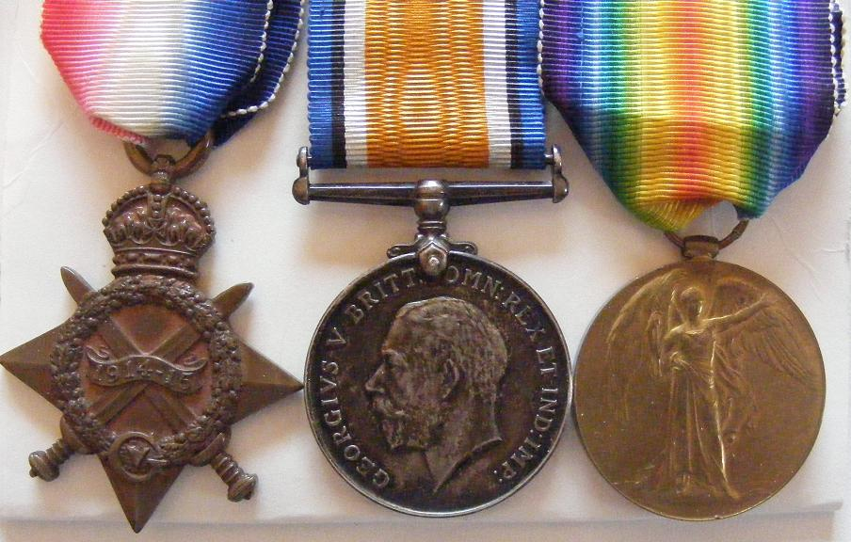

1914 - 1915 STAR:
The star was awarded to all who saw service in any theatre of war against the central powers
between 05 August 1914 and 31 December 1915 except those eligible for the 1914 Star.

BRITISH WAR MEDAL:
This medal was instituted to record the successful conclusion of the First World War.
VICTORY MEDAL:

The medal was awarded to all ranks of the fighting forces, to civilians under contract,
and others employed with military hospitals who actually served on the establishment
of a unit in a theatre of war between 05 August 1914 and 11 November 1918 (inclusive).

http://www.internet-promotions.co.uk/archives/caithness/63rdrn.htm

