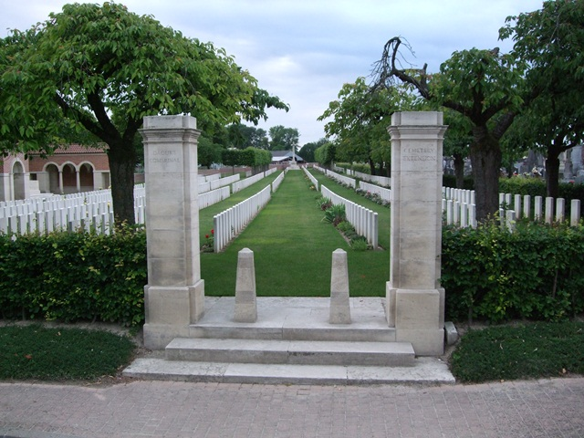

Daours Communal Cemetry, Extention, France.
Burial Place of Thomas Couch, age 37, KOSB, 6th Btn
Died 5th July 1916, Regimental No. 16455.
Husband of Margaret Couch, 23 Green St , Stonehouse.

